Merge Intervals

1) Definition
Used when working with a collection of intervals (ranges) such as [start, end] to combine all overlapping intervals into non overlapping ones.
Example:
Input: [[1,3], [2,6], [8,10], [15,18]]
Output: [[1,6], [8,10], [15,18]]

2) When to Apply (Use Cases)
Problems involving ranges, segments, or time intervals where overlap handling is required.
Common scenarios:
- Calendar event merging
- Finding free time slots from schedules
- CPU or task scheduling
- Range compression
- Network or genome interval processing
- Union of segments
- Removing overlaps

3) Core Approach
Step 1: Sort
Sort all intervals by starting time.
Step 2: Iterate & Merge
- Initialize result list with the first interval
- For each next interval:
  - If current.start ≤ last.end → overlap exists
→ merge by updating end = max(last.end, current.end)
  - Else → no overlap
→ add interval to result

4) Pseudocode
sort intervals by start
result = []
for interval in intervals:
if result is empty OR interval.start > result.last.end:
add interval to result
else:
result.last.end = max(result.last.end, interval.end)
return result

5) Complexity
- Sorting: O(n log n)
- Merge scan: O(n)
- Total: O(n log n)
- Space: O(n) (for output)

6) Why This Works
- Sorting ensures potential overlaps appear next to each other
- Linear scan merges in one pass
- No need to revisit previous intervals

7) Key Benefits
- Efficient for large datasets
- Simple implementation
- Foundation for many interval problems
- Extends to union, intersection, gap finding

8) Recognizing the Pattern
Look for problems that mention:
- Intervals / ranges
- Overlap handling
- Merge / combine
- Scheduling or calendar
- Meetings or events
- Covering ranges
- Minimizing overlaps
- Finding gaps

9) Typical Steps Summary
Sort → Traverse → Merge → Return

10) Important LeetCode Problems (Easy → Hard)
🟢 Easy
- 252 — Meeting Rooms
- 253 — Meeting Rooms II (sometimes medium depending on approach)
🟡 Medium
- 56 — Merge Intervals
- 57 — Insert Interval
- 435 — Non overlapping Intervals
- 452 — Minimum Number of Arrows to Burst Balloons
- 986 — Interval List Intersections
- 1288 — Remove Covered Intervals
- 436 — Find Right Interval
- 1094 — Car Pooling
- 228 — Summary Ranges
🔴 Hard / Advanced Variants
- 715 — Range Module
- 352 — Data Stream as Disjoint Intervals
- 218 — The Skyline Problem (related interval sweep)

If you want, I can also provide:
- Complete Interval Problems Master Sheet
- All interval patterns (merge, sweep line, heap based, difference array)
- Java implementations for each pattern
- Interview ready notes PDF
Just ask.

You said:
Complete Interval Problems Master Sheet All interval patterns (merge, sweep line, heap based, difference array)

ChatGPT said:
🧠 Complete Interval Problems Master Sheet

🔷 1) Merge Intervals Pattern (Sorting + Linear Scan)
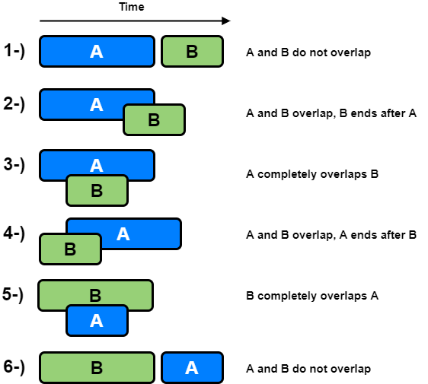
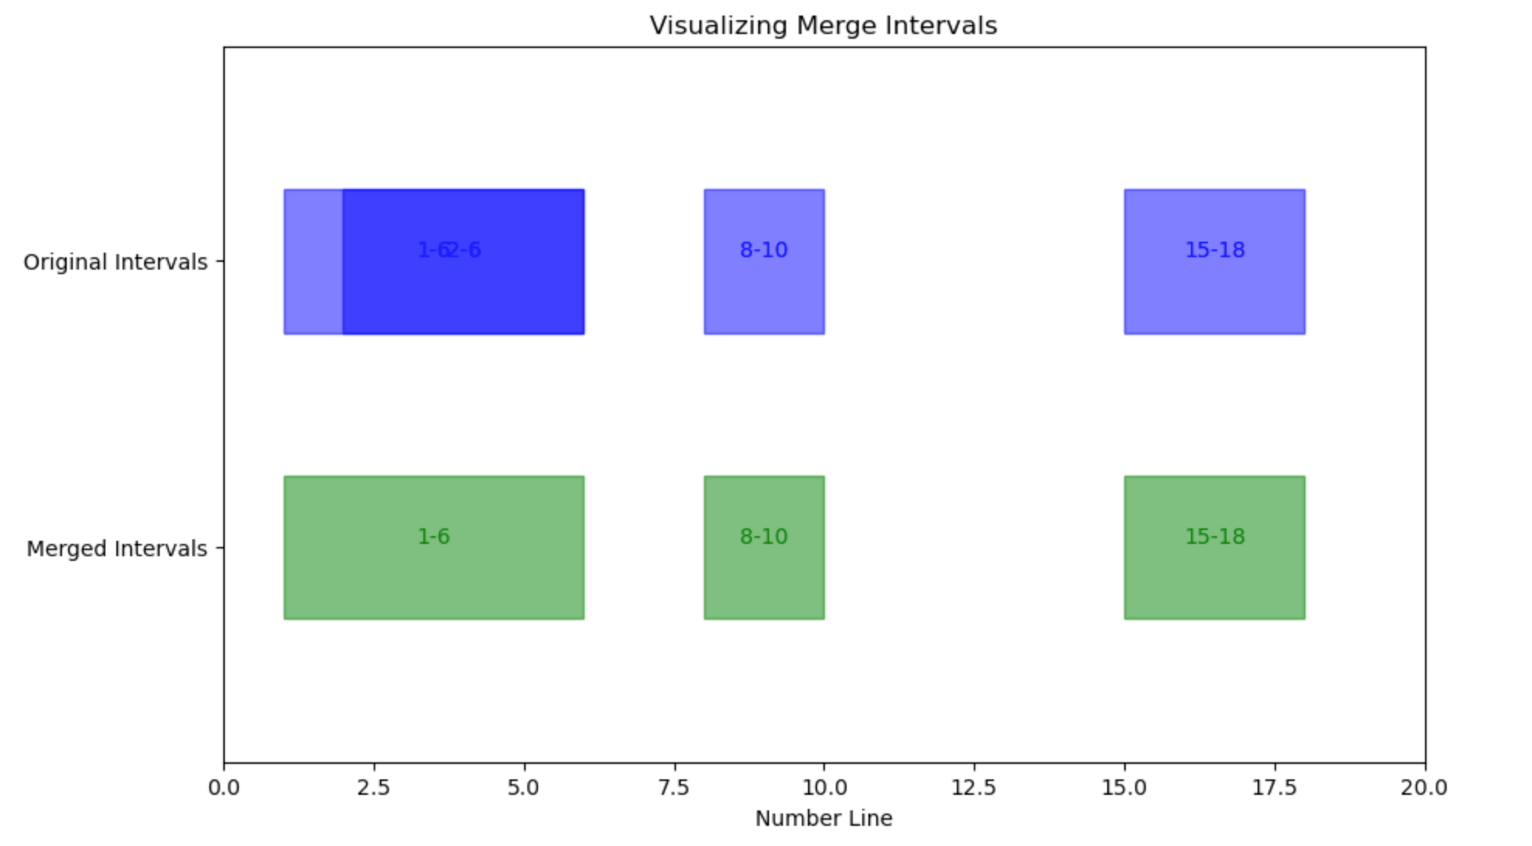
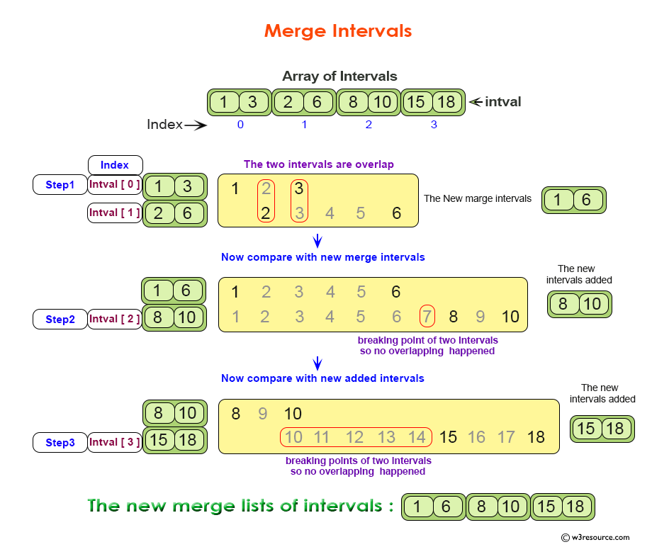
4
✅ When to Use
- Combine overlapping ranges
- Produce non overlapping intervals
- Union of segments
- Remove overlaps
⚙️ Core Idea
Sort by start → scan → merge with previous
🧩 Template Logic
sort intervals by start
for each interval:
if overlap with last:
merge
else:
add new interval
⏱ Complexity
O(n log n) due to sorting
🔥 Key LeetCode Problems
🟢 Easy
- 252 Meeting Rooms
🟡 Medium
- 56 Merge Intervals
- 57 Insert Interval
- 435 Non overlapping Intervals
- 452 Minimum Arrows to Burst Balloons
- 1288 Remove Covered Intervals
- 228 Summary Ranges
🔴 Hard
- 352 Data Stream as Disjoint Intervals
- 715 Range Module

🔷 2) Sweep Line Pattern (Events Timeline)
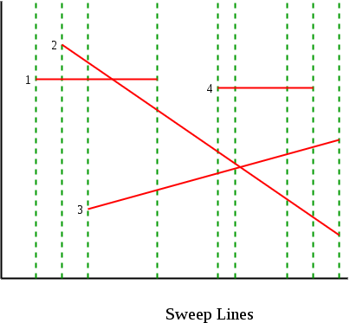
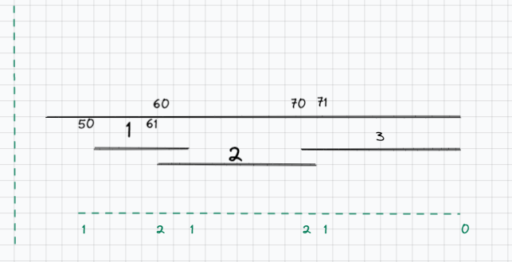
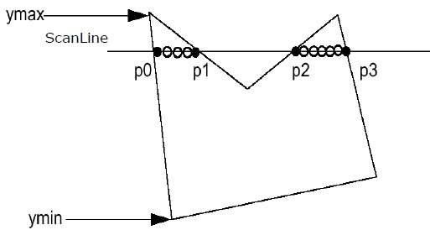
4
✅ When to Use
- Count simultaneous intervals
- Maximum overlaps
- Timeline processing
- Active intervals at any time
⚙️ Core Idea
Convert intervals into events:
- Start → +1
- End → −1
Sort events → sweep through timeline
🧩 Template Logic
events = []
for each interval:
add (start, +1)
add (end, -1)
sort events
active = 0
for event:
active += event.value
⏱ Complexity
O(n log n)
🔥 Key Problems
🟡 Medium
- 253 Meeting Rooms II
- 1094 Car Pooling
- 731 My Calendar II
🔴 Hard
- 732 My Calendar III
- 218 Skyline Problem

🔷 3) Heap Based Interval Pattern (Priority Queue)

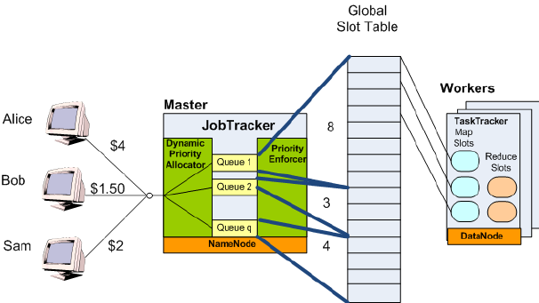
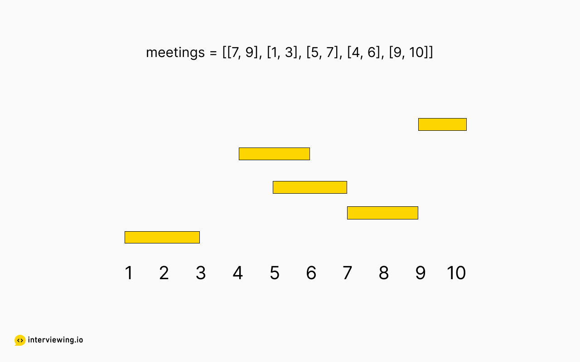
4
✅ When to Use
- Allocate resources (rooms, CPUs)
- Track earliest finishing interval
- Multiple active intervals
⚙️ Core Idea
Sort by start time
Use min heap of end times
- Remove finished intervals
- Add current end
- Heap size = active resources
🧩 Template Logic
sort intervals by start
heap = empty min heap
for interval:
if heap.top <= interval.start:
pop
push interval.end
⏱ Complexity
O(n log n)
🔥 Key Problems
🟡 Medium
- 253 Meeting Rooms II (heap approach)
- 1094 Car Pooling
🔴 Hard
- 759 Employee Free Time

🔷 4) Difference Array / Prefix Sum Pattern
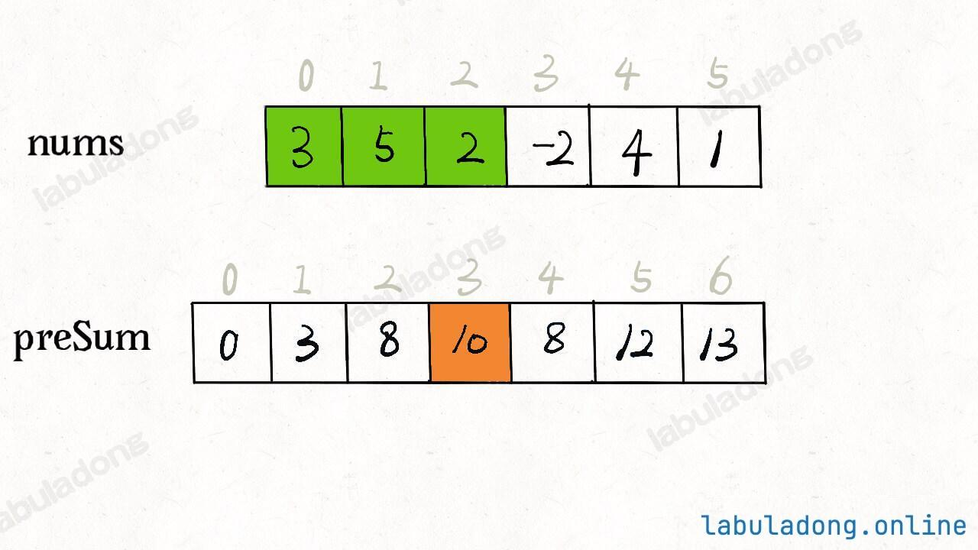
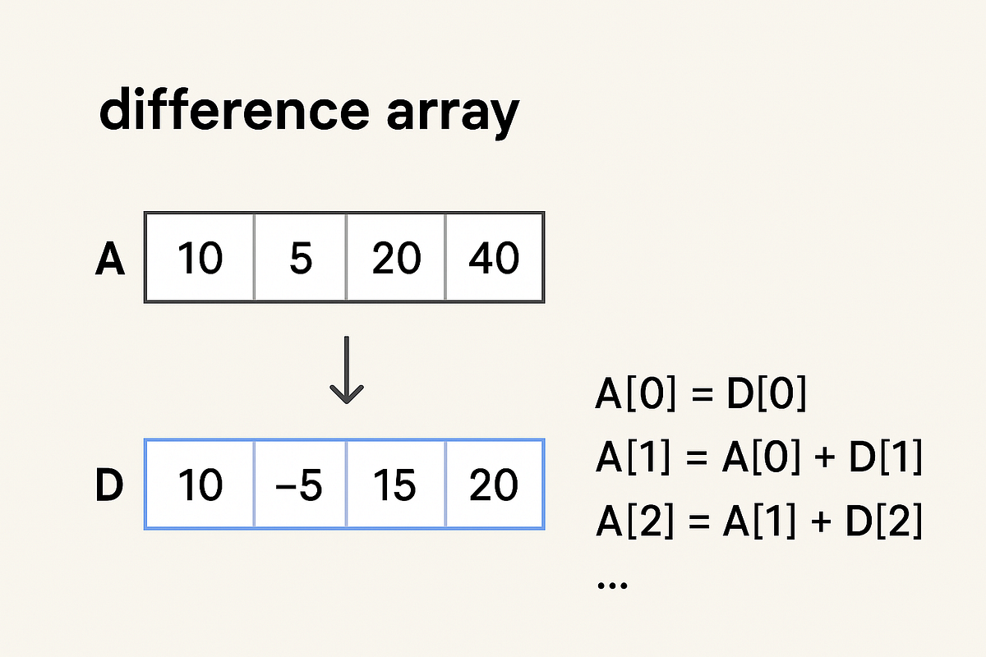
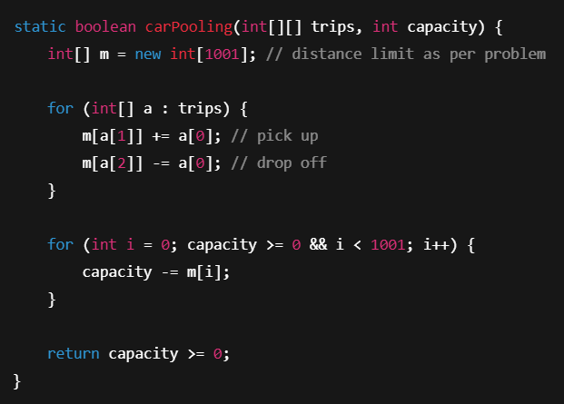
4
✅ When to Use
- Range updates
- Capacity constraints
- Check if overlaps exceed limit
- Discrete timeline problems
⚙️ Core Idea
Mark changes only at boundaries:
- diff[start] += value
- diff[end] −= value
Prefix sum reconstructs actual values
🧩 Template Logic
diff[start] += x
diff[end] -= x
for i:
curr += diff[i]
⏱ Complexity
O(n + range)
🔥 Key Problems
🟡 Medium
- 1094 Car Pooling
- 370 Range Addition
🔴 Hard
- 732 My Calendar III (optimized versions)

🧩 BONUS: Other Important Interval Techniques
⭐ Two Pointer on Sorted Intervals
Used for intersections of two interval lists
Problems:
- 986 Interval List Intersections

⭐ Greedy Interval Scheduling
Pick earliest ending interval first
Problems:
- 435 Non overlapping Intervals
- 452 Minimum Arrows

⭐ Binary Search on Intervals
Search compatible interval
Problems:
- 436 Find Right Interval

🚀 Pattern Selection Guide (Interview Shortcut)
Problem Clue | Pattern
Merge overlaps | Merge Intervals
Max simultaneous intervals | Sweep Line / Heap
Allocate rooms/resources | Heap
Range updates | Difference Array
Find intersections | Two Pointer
Remove minimum overlaps | Greedy

